

Service Broker Authorization API

Author: Jud Harward
Last Modified: 1/24/05
By: Chris Felknor

Table of Contents

Table of Contents 2
Introduction 3
Grants 3
public struct Grant 3
Qualifiers 5
Explicit vs. Implicit Grants 7
Service Broker Authorization Policy and Architecture 9
Service Broker Default Authorization Policy 10
Authorization API 11
Authentication API 11
Administrative API 11
Experiment Storage API 12
Client to Service Broker API 13
Methods 14
Grant Management Methods 14
AddGrant 14
RemoveGrants 14
ListGrantIDs 15
GetGrants 15
FindGrants 15
CheckAuthorization 16
Qualifier Management Methods 17
Add Qualifier 17
GetQualifierID 17
GetQualifier 18
AddQualifierParent 18
RemoveQualifierParent 19
SetQualifierParent 19
RemoveQualifiers 20
ListQualifierIDs 20
ListQualifierParents 20
LIstQualifierChildren 21
ListQualifierDescendents 21
IsQualifierDescendant 21

Introduction
The Authorization API describes the mechanisms used by the Service Broker to assign different levels of access to Service Broker functionality to different users. The Service Broker attempts to provide good, common sense default behavior that can be tailored to a particular institution or class’s needs using the Service Broker’s administrative web interface. This document describes the low level internal calls that implement this business logic. This document, therefore, addresses developers who will maintain and extend the Service Broker rather than administrators who will configure a particular Service Broker installation. The introductory material in the first half of this document, however, will provide useful background for administrators, but they will not need to master the actual method calls discussed in the second half.
The approach taken here was inspired by the Authorization API of the Open Knowledge Initiative (OKI: http://web.mit.edu/oki/). The OKI Authorization and associated APIs had not stabilized at the point the Service Broker implementation had to go ahead. In a future Service Broker release, we may bring the Service Broker Authorization API more strictly in accord with OKI.

Grants
Service Broker permissions are implemented using two mechanisms. Experiment records and other user-generated documents preserve the identity of their creator (“the owner”). “The owner” generally retains special permissions over such documents. Other permissions implementing class and site policy are established using an administrative interface that manages instances of the Grant type. A Grant instance combines three concepts: the agent (either a single user or a group of users gaining the permission specified by the Grant), the function (which specifies the type of permission), and the qualifier (which specifies the Service Broker resource to which the new permission applies). The Agent is specified by the int ID of the appropriate User or Group. The function is drawn from a fixed set of strings known to the Service Broker implementation, e.g., “useLabServer” or “administerGroup”. The anatomy of the Qualifier will be discussed in detail below, but a simple example will help to get us started. If the function of a Grant is the String “useLabServer”, then we would expect the Qualifier to specify which Lab Server the Grant applies to.

public struct Grant
{
public int grantID
public int agentID
public string function
public int qualifierID
}
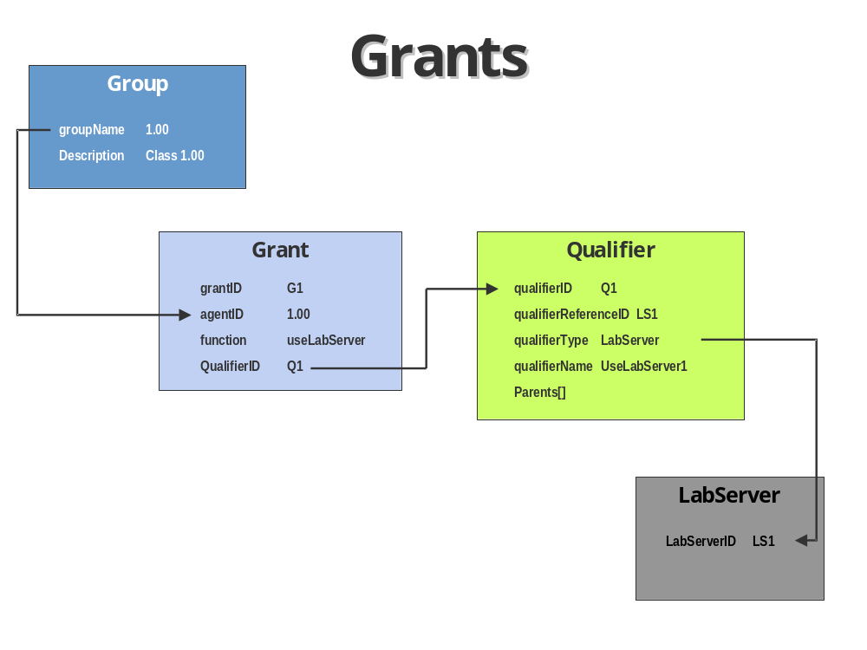
Figure 1
The following table lists the function strings defined to implement the authorization policy for the first generation Service Broker. Type checking between function and Qualifier type is not enforced, so the second column only indicates typical usage. This allows a particular Service Broker implementation to extend the set of known Qualifier types.
Function | Normal Qualifier Type
useLabClient | LabClient
useLabServer | LabServer
readExperiment | Experiment or ExperimentCollection
writeExperiment | Experiment or ExperimentCollection
addMember | Group
administerGroup | Agent
superUser

The superUser function (which has no context) implies all other grants as well as being required for the most privileged administrative functions, such as registering a new Lab Server.

Qualifiers
Agents form an implicit hierarchy by virtue of the structure of group membership. Members of Groups can be Users or other Groups. Qualifiers form an explicit hierarchy; that is, administrators and Service Broker default logic explicitly construct the Qualifier hierarchy to model nested permission domains appropriate to site policy.
An example will make this clearer (please refer to Figure 2 on page 7). At MIT, 1.00 is the designation of one of the basic programming courses. If this course were to use a Service Broker to administer online lab sessions, a standard way to organize students and staff would be to make the students members of a Group with the groupName, “1.00”, and course staff members of a Group with groupName “1.00Staff”. As we shall see, by making the 1.00Staff group a subgroup of group 1.00, staff members will inherit all the privileges of students in the class. Typical administrative policy would grant course staff control over all class resources, e.g., student experiment records. Individual students have permission to view and modify their own experiment records because they “own” those resources. By default, they may neither view nor modify experiments that belong to anyone else. The professor teaching 1.00 might want to allow all students to view experiment results from all students but only to modify or delete their own.
How would we establish this particular policy using Grants and Qualifiers? There are two separate sets of permissions to be established: (1) students can view all experiment records but only write their own, and (2) course staff can read and write all experiment records. The Service Broker automatically creates a Qualifier for each experiment record when the experiment is run. It is default policy to create these Qualifiers as the children of a single parent Qualifier of type “ExperimentCollection”. To implement the first set of permissions, an administrator would create a Grant that would associate the 1.00 group with the “readExperiment” function on the “ExperimentCollection” Qualifier node belonging to the class. This would allow members of the 1.00 group to read all resources that are descended from the ”ExperimentCollection” node. Staff would gain the same access because the staff group is a subgroup of the 1.00 group. To implement the second set of permissions, the administrator would need to create a second Grant associating the more restrictive staff subgroup with the more powerful “writeExperiment” function applied to the same “ExperimentCollection” Qualifier node. Now let’s look at these mechanisms in more detail.
Qualifiers possess a qualifierReferenceID (int), qualifierTypeID (int), and qualifierName (string) specified at the time the Qualifier is created via the AddQualifier()method. This method assigns the new Qualifier a unique int qualifierID. The qualifierReferenceID acts, in database terms, like a foreign key and identifies a resource represented by the Qualifier. It will usually be an ID in the ID space corresponding to the qualifierTypeID. We stated above that the Service Broker creates a Qualifier whenever a new experiment record is stored. The qualifierReferenceID of this Qualifier is the same as the experiment ID, and the qualifierTypeID corresponds to “Experiment”.
Some Qualifiers do not possess a qualifierReferenceID (==-1). This usually occurs when administrators want to group Qualifiers of a given type into a collection represented by a new Qualifier, in order to simplify the assignment of permissions, as in the case of the “ExperimentCollection” node above. As an additional example, if students in a particular class will be executing experiments on three separate Lab Servers, it might be useful to represent each Lab Server by a Qualifier of type “LabServer”, and then to make these Qualifiers the children of a new Qualifier that represents the set of three Lab Servers. The qualifierReferenceIDs of the first three Qualifiers will be the corresponding LabServer IDs. But what should be the qualifierReferenceID of the fourth Qualifier, the one that represents the collection? Since the collection of Lab Servers is solely defined by the hierarchy of Qualifiers and is not represented by any other object in the system, there is no reasonable candidate for the qualifierReferenceID; it is set to the special value -1.
In order to administer Grants, however, we must be able to unambiguously identify this collection node. We might want to add a new Lab Server to the collection by linking the Qualifier representing the new Lab Server in as a child. More specifically, a Qualifier must possess a qualifierName if it does not have a qualifierReferenceID (==-1). If the qualifierReferenceID is not -1, then the combination of qualifierTypeID and qualifierReferenceID must be unique. If qualifierReferenceID is -1, then the combination of qualifierTypeID and qualifierName must be similarly unique. This implies that a resource can only appear once in the Qualifier hierarchy.
Qualifier is the class that implements this concept internally.
public struct Qualifier
{
public int qualifierID;
public int qualifierReferenceID;
public int qualifierType;
public string qualifierName;
public Qualifier[] parents;
}
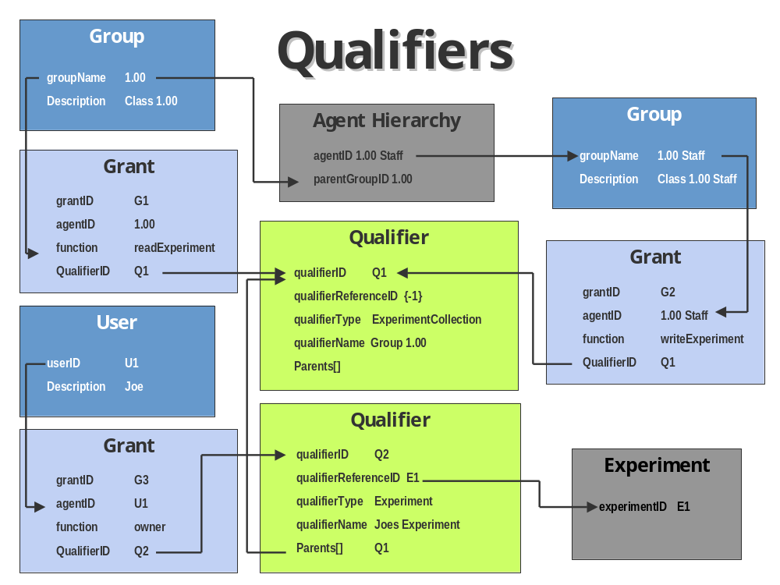

Figure 2

Explicit vs. Implicit Grants
A call to AddGrant() (see page 15) defines an explicit Grant or permission. The Service Broker authorization architecture also considers implicit grants when checking authorization via CheckAuthorization() and other calls. An implicit grant is a grant implied by an existing explicit grant and the Agent and Qualifier hierarchies that have been created.
More formally, a Grant {agentID1, function, qualifierID1} will be considered valid if the grant is explicitly registered with the Service Broker or if there is a second grant {agentID2, function, qualifierID2} explicitly registered for which
- agentID1=agentID2 or agentID1 is a descendant of agentID2, and
- qualifierID1=qualifierID2 or qualifierID1 is a descendant of qualifierID2.
If it is not the case that agentID1 = agentID2 and qualifierID1 = qualifierID2, then the second Grant is only implied by the first. The second Grant does not possess its own grantID or its own Grant object.
As an example, consider the two hypothetical Groups, 1.00 and 1.00Staff, used in the example above. Students gain permission to read other students’ experiment records and course staff to delete those records through implicit grants that are implied by the corresponding explicit grants on the “ExperimentCollection” Qualifier.
Let us work through a more complicated example (illustrated in Figure 3 on page 10). The Group objects representing both these groups possess a required unique string groupName and an optional string description. In this example, the strings “1.00” and “1.00Staff” serve as the groupNames for their respective groups. A user wishing to invoke the ListMemberIDsInGroup() method on the 1.00 group requires an “administerGroup” Grant for the group. The groupID corresponding to group 1.00 cannot serve as a Qualifier directly, but the system can create a Qualifier that represents group 1.00. This Qualifier will have an arbitrary, unique qualifierID (qualID1) but its qualifierTypeID will correspond to Group and its qualifierReferenceID will be that of group 1.00, i.e. the groupID for the Group that the Qualifier represents. A second Qualifier with the qualifierReferenceID corresponding to 1.00Staff (qualID2) will represent the group containing the course’s teaching staff.
The head teaching assistant for the course (userName=jsmith) will be a member of the 1.00Staff group, and may well possess the following explicit Grant: {grantID1, userID of “jsmith”, “administerGroup”, qualID2}. This grant would allow him to list the IDs of all members in the 1.00Staff group (and add new members to the group). But note that this Grant doesn’t give jsmith any Grant, explicit or implied to administer the supergroup 1.00. If jsmith also possesses the “administerGroup” Grant on the Qualifier with the reference to Group 1.00, he may choose to add the Grant {grantID2, groupID of “1.00Staff”, “administerGroup”, qualID1}. The two most important points to note from this example are, first, that a Grant identifies the target of its function indirectly through the qualifierReferenceID of its Qualifier, and second, that although subgroups inherit their parent group’s Agent permissions, Qualifiers of subgroups do not inherit permissions on their supergroups. If they did, then all staff members could add new members to the 1.00Staff group.
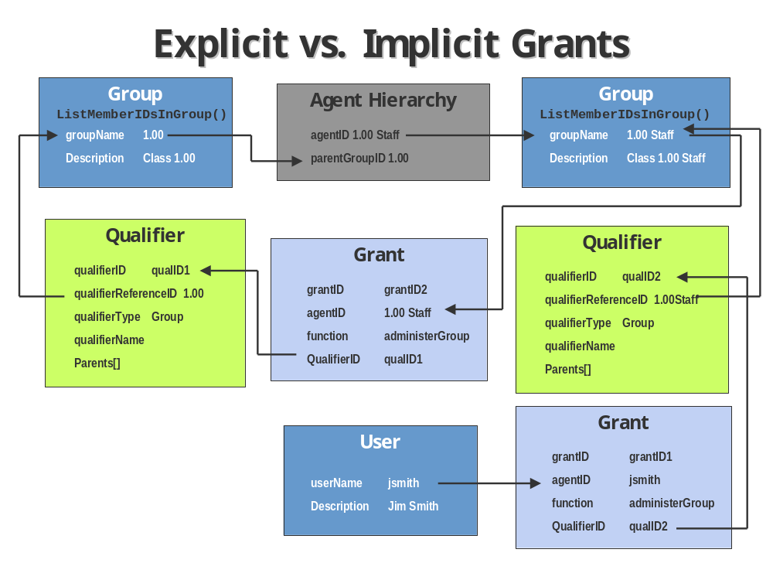
Figure 3

Service Broker Authorization Policy and Architecture
Authorization requires both an internal system architecture and an external social design. The social design or policy may differ from campus to campus. The Service Broker should not specify and enforce a particular set of rules that stipulate who can do what. It should allow system administrators to implement whatever policy a particular campus requires.
At the same time, the Service Broker architecture and implementation must follow certain internal practices if security and authorization policy is to be consistently enforced. The user interacts with the Service Broker through a web browser or a client application. The low level Service broker APIs (Service Broker Administrative API, Service Broker Experiment Storage API, Service Broker Authorization API, Service Broker Authentication API) assume they are executed by trusted code that checks the user’s permission to perform the actions in question by calling methods in the Service Broker Authorization (Authz) API discussed in this document. The user’s identity must have been determined previously using mechanisms defined in the Service Broker Authentication (Authn) API.
SB
Authn
API
SB
Authz
API
SB
Admin
API
SB
Experiment
Storage API
ASP.NET Administrator

Client Web Service API
Browser
Client
Application
Trusted Code To Check Authorization
Lab
Server
Service Broker
Lab Server Web Service API

Service Broker Default Authorization Policy
Service Broker authorization policy should be table driven so that it can be configured for individual campuses. The default policy that will be implemented by the distribution version of the Service Broker without any customization is expressed in the following table. Each row of the table corresponds to one of the methods available in the insecure low level APIs (Authorization, Authentication, Administrative, Experiment Storage) or the top level Client To Service Broker API. If the Function is listed as trusted, then the method should only be called during the execution of trusted administrative code and not directly at the behest of a user. The anyone designation indicates that any user may execute the method. The owner designation indicates that only the owner of the designated item(s) may execute the method. In all other cases, the row corresponding to a method lists the Function and QualifierType of the default Grant required to execute the method at the command of a user (Agent).
We expect that the mapping of Grant to API method will be implemented using tables loaded at Service Broker startup. This implies that the authorization policy could be modified at a particular site by modifying these configuration files.

Authorization API
Method | Function | QualifierType
AddGrant | superUser
RemoveGrants | superUser
ListGrantIDs | anyone
GetGrants | anyone
FindGrants | anyone
CheckAuthorization | trusted
AddQualifier | trusted
AddQualifierParent | trusted
GetQualifierID | trusted
GetQualifier | trusted
RemoveQualifierParent | trusted
SetQualifierParent | trusted
RemoveQualifiers | trusted
ListQualifierIDs | trusted
ListQualifierParents | trusted
ListQualifierChildren | trusted
ListQualifierDescendants | trusted
IsQualifierDescendant | trusted

Authentication API
Method | Function | QualifierType
Authenticate | trusted
CreateNativePrincipal | superUser
RemoveNativePrincipals | superUser
ListNativePrincipals | superUser
SetNativePassword | superUser

Administrative API

Method | Function | QualifierType
AddLabServer | superUser
RemoveLabServers | superUser
ModifyLabServer | superUser
ListLabServerIDs | anyone
GetLabServers | anyone
GenerateServerID | superUser
GetServerID | superUser
GenerateIncomingServerPasskey | superUser
GetIncomingServerPasskey | superUser
RegisterOutgoingServerPasskey | superUser
GetOutgoingServerPasskey | superUser
AddLabClient | superUser
RemoveLabClients | superUser
ModifyLabClient | superUser
ListLabClientIDs | anyone
GetLabClients | anyone
SetUserXMLExtensionSchema | superUser
AddUser | addMember | Group
RemoveUsers | superUser
ModifyUser | superUser
ListUserIDs | superUser
ListOrphanedUserIDs | superUser
GetUsers | administerGroup | Group
GetUsersNames | anyone
AddGroup | superUser
RemoveGroups | superUser
ListGroupIDs | anyone
GetGroups | superUser
AddMemberToGroup | addMember | Group
RemoveMembersFromGroup | administerGroup | Group
ListUserIDsInGroupRecursively | administerGroup | Group
ListMemberIDsInGroup | administerGroup | Group
ListGroupsForAgent | anyone
ListGroupsForAgentRecursively | anyone
IsAgentMember | anyone
NotifyUsers | administerGroup | Group
SaveClientItemValue | owner
GetClientItemValue | owner
RemoveClientItems | owner
ListClientItems | owner
AddSystemMessage | administerGroup | Group
RemoveSystemMessages | administerGroup | Group
ModifySystemMessage | administerGroup | Group

Experiment Storage API
Method | Function | QualifierType
SetResultXMLExtensionSchema | superUser
SetBlobXMLExtensionSchema | superUser
SaveExperimentSpecification | writeExperiment | Experiment
RetrieveExperimentSpecification | readExperiment | Experiment
SaveSubmissionReport | writeExperiment | Experiment
SaveResultReport | writeExperiment | Experiment
RetrieveExperimentResult | readExperiment | Experiment
RetrieveLabConfiguration | readExperiment | Experiment
SaveExperimentAnnotation | writeExperiment | Experiment
RetrieveExperimentAnnotation | readExperiment | Experiment
RemoveExperiments | writeExperiment | Experiment
GetExperimentInformation | readExperiment | Experiment
FindExperimentIDs | readExperiment | Experiment
SaveBlobObject | writeExperiment | Experiment
GetBlobObjects | readExperiment | Experiment
RemoveBlobObjects(int[]) | writeExperiment | Experiment
RemoveBlobObjects(int[],int[]) | writeExperiment | Experiment
GetBlobInformation | readExperiment | Experiment

Client to Service Broker API
Method | Function | QualifierType
GetLabStatus | useLabServer
GetEffectiveQueueLength | useLabServer
GetLabInfo | useLabServer
GetLabConfiguration | useLabServer
Validate | useLabServer
Submit | useLabServer
Cancel | useLabServer
GetExperimentStatus | useLabServer
RetrieveResult | useLabServer
SaveClientItem | owner
GetClientItem | owner
RemoveClientItem | owner
ListClientItems | owner
Annotate | writeExperiment | Experiment

Methods

Grant Management Methods

AddGrant
Purpose:
/* Adds a grant to the agent (User or Group) agentID. */
Arguments:
int agentID
/* The ID of the agent to which the grant is to be added. */
string function
/* The function of grant to be added; function must be one of the fixed set of Function strings recognized by the Service Broker. */
int qualifierID
/* The ID of a previously created Qualifier whose qualifierType is appropriate to the function, if the Function type requires one; otherwise null. */
Returns:
int ID
/* The ID of the new Grant if
- agentID specifies a registered user or group
- function is a legitimate function type
- qualifierID is a recognized ID of an appropriate qualifierType for the function (in the case where qualifierID is specified).
In addition, the specified grant must not already have been made to the specified agent. If any of these conditions fails, then this method returns null. Note that most of the other Service Broker AddXXX() methods specify the ID of the object being added; the AddGrant() method does not do this; grantIDs are arbitrary ints generated by the Service Broker implementation. */

RemoveGrants
Purpose:
/* Removes previously registered grants. The removal of a grant should not affect any Service Broker calls currently in progress, but it can prevent the execution of later related method calls. For instance, if the revoked grant permits a group to use a particular lab server, then any experiments in progress should run to completion, but users will be unable to retrieve the corresponding results through the Service Broker. */
Arguments:
int[] grantIDs
/* An array of the IDs of previously registered grants. */
Returns:
int[] IDs[]
/* An array of the IDs of the grants that could not be removed, i.e., those for which the operation failed. */

ListGrantIDs
Purpose:
/* Lists the IDs of all grants registered with the Service Broker. */
Arguments:
None

Returns:
int[] IDs[]
/* An array of IDs for all registered grants. */

GetGrants
Purpose:
/* Returns an array of the immutable Grant objects for the registered grants whose IDs are supplied in grantIDs. */
Arguments:
int[] grantIDs
/* The IDs identifying the registered grants whose information is to be retrieved. */
Returns:
Grant[] grants[]
/* An array of Grant objects describing the registered grants specified in grantIDs; if the nth grantID does not correspond to a grant, the nth entry in the return array will be null. */

FindGrants
Purpose:
/* Enumerates the IDs of all explicit grants matching the specification of the arguments; any or all of the arguments may be null, in which case, the method does a wildcard match on the null argument(s). (A FindGrants() with all the arguments null is equivalent to a ListGrantIDs()). */
Arguments:
int agentID
/* The ID of the agent for which matching grants are sought. */
string function
/* The Function for which matching grants are sought; Function must be one of the fixed set of function type strings recognized by the Service Broker. */
int qualifierID
/* The ID of the Qualifier (associated with the function, if the function type requires one; otherwise -1) for which matching grants are sought. */
Returns:
int[] grantIDs[]
/* An array of grantIDs of any grants that match the specification. */

CheckAuthorization
Purpose:
/* Determines whether the specified agent has the appropriate authorization specified by function and qualifierID; both explicit and implicit grants are checked; there is no wildcard matching and none of the arguments may be null. */
Arguments:
int agentID
/* The ID of the agent for which authorization is being checked. */
string function
/* The Function for which authorization is being checked. */
int qualifierID
/* The qualifierID of a previously created Qualifier whose qualifierType is appropriate to the function, if the function type requires one; otherwise -1. */
Returns:
bool isAuthorized
/* true if the agent is authorized to perform the function with the qualifier (if present); false otherwise. */

Qualifier Management Methods

Add Qualifier
Purpose:
/* Creates a new node in a Qualifier hierarchy. */
Arguments:
int qualifierReferenceID
/* The ID of the resource represented by the qualifier (null if not necessary); if qualifierReferenceID is present, the pair qualifierReferenceID and type must be unique. */
int type
/* The ID of one of the statically configured qualifierTypes registered with the Service Broker. */
string name
/* An identifier used to distinguish this Qualifier in administrative listings; if qualifierReferenceID is not present, this field is required, and the combination of type and name must be unique. */
int parentQualifierID
/* The ID of a previously created Qualifier to serve as the parent of the Qualifier being added; the parentQualifierID locates the new Qualifier in the hierarchy; additional parents may be added by the AddQualifierParent() method. */
Returns:
int qualifierID
/* The ID of the new qualifier if it is successfully created, -1 otherwise. */

GetQualifierID
Purpose:
/* Returns the qualifier ID of the specified qualifier. */
Arguments:
int qualifierReferenceID
/* The ID of the resource represented by the Qualifier (null if not necessary. */
int qualifierType
/* The ID of one of the statically configured qualifierTypes registered with the Service Broker; iLab does not support a single ID space, so qualifierReferenceIDs are only unique within a single qualifier. */
Returns:
int ID
/* The ID of the specified qualifier if it exists, -1 otherwise. Note that there can be at most one Qualifier of a given qualifierType with a particular qualifierReferenceID. */

GetQualifier
Purpose:
/* Returns the qualifier corresponding to the specified qualifier ID. */
Arguments:
int qualifierID
/* The ID of the qualifier to be retrieved. */
Returns:
Qualifier qualifier
/* The qualifier object corresponding to the specified qualifier ID (if it exists), null otherwise. */

AddQualifierParent
Purpose:
/* Adds a parent to the specified node in a qualifier hierarchy. */
Arguments:
int qualifierID
/* The ID of a previously created Qualifier to which the new parent is being added.*/
int parentQualifierID
/* The ID of a previously created Qualifier that will serve as an additional parent of the Qualifier designated by qualifierID; the addition of the parent must preserve the acyclic property of the Qualifier graph. */
Returns:
bool success
/* true if the parent qualifier was successfully added, false otherwise. */

RemoveQualifierParent
Purpose:
/* Removes a parent from the specified node in a qualifier hierarchy; the node losing a parent must possess an additional parent so it does not become de-rooted (cf. SetQualifierParent()). */
Arguments:
int qualifierID
/* The ID of a previously created Qualifier that is to have a parent removed. */
int parentQualifierID
/* The ID of a previously created Qualifier that is one of the two or more parents of the Qualifier designated by qualifierID. */
Returns:
bool success
/* true if the parent qualifier was successfully removed, false otherwise. */

SetQualifierParent
Purpose:
/* Makes a previously created qualifier node specified by parentQualifierID the single parent of the node specified by key in a qualifier hierarchy. The operation will complete only if it preserves the acyclic character of the Qualifier graph. Note this is the only way to make a previously created Qualifier node of a hierarchy a new root. */
Arguments:
int qualifierID
/* The ID of a previously created Qualifier that will receive the new parent. */
int parentQualifierID
/* The ID of a previously created Qualifier that will become the new parent of the Qualifier designated by qualifierID. */
Returns:
bool success
/* true if the parent qualifier was successfully changed, false otherwise. */

RemoveQualifiers
Purpose:
/* Removes previously registered Qualifiers in order from the qualifier graph; all removed qualifiers must be childless nodes of the graph when they are removed. */
Arguments:
int[] qualifierIDs
/* An array of the qualifierIDs of previously registered qualifiers to be unregistered; the qualifiers are removed in the order in which they are listed in this array. */
Returns:
int[] qualifierIDs
/* An array of the Qualifier IDs of the qualifiers that could not be removed, i.e., those for which the operation failed. */

ListQualifierIDs
Purpose:
/* Lists the IDs of all qualifiers of the specified type. */
Arguments:
int[] qualifierTypeIDs
/* The IDs of the types of qualifiers sought; if qualifierTypeIDs is null, list all qualifierIDs of all types. */
Returns:
int[] qualifierIDs
/* An array of IDs of all matching qualifiers. */

ListQualifierParents
Purpose:
/* Lists the IDs of all parent Qualifiers of the specified Qualifier. */
Arguments:
int childQualifierID
/* The ID of the Qualifier whose parents are sought. */
Returns:
int[] qualifierIDs
/* An array of qualifierIDs of all parent Qualifiers, otherwise an empty array */

LIstQualifierChildren
Purpose:
/* Lists the IDs of all child Qualifiers of the specified Qualifier. */
Arguments:
int parentQualifierID
/* The ID of the Qualifier whose children are sought. */
Returns:
int[] qualifierIDs
/* An array of Qualifier IDs of all child qualifiers, otherwise an empty array. */

ListQualifierDescendents
Purpose:
/* Lists the IDs of all Qualifiers that are descendants of the given qualifierID. */
Arguments:
int ancestorQualifierID
/* The ID of the Qualifier whose descendants are sought. */
bool breadthFirst
/* If true, descendants are listed in breadth first order, otherwise depth first postorder, which happens to be the correct order for deleting subtrees in which all nodes are singly parented. */
Returns:
int[] qualifierIDs
/* An array of qualifierIDs of all descendant Qualifiers. */

IsQualifierDescendant
Purpose:
/* Checks whether one Qualifier is the descendant of another. */
Arguments:
int qualifierID1
/* The descendent Qualifier in question. */
int qualifierID2
/* The ancestor Qualifier in question. */
Returns:
bool isDescendant
/* true if qualifierID1 is a descendant of qualifierID2. */

